1.**write a program to take a associative array and sort it using value ,in both ascending and descending order.**

<html>

<body>

<?php

$salaries = array("Ajay" => 55000, "Sunil" => 19000, "Vijay" => 5000);

asort($salaries);

foreach($salaries as $x => $x_value) {

echo "Key=" . $x . ", Value=" . $x_value;

echo "<br>";

}

?>

</body>

</html>

<html>

<body>

<?php

$salaries = array("Ajay" => 55000, "Sunil" => 19000, "Vijay" => 5000);

arsort($salaries);

foreach($salaries as $x => $x_value) {

echo "Key=" . $x . ", Value=" . $x_value;

echo "<br>";

}

?>

</body>

</html>

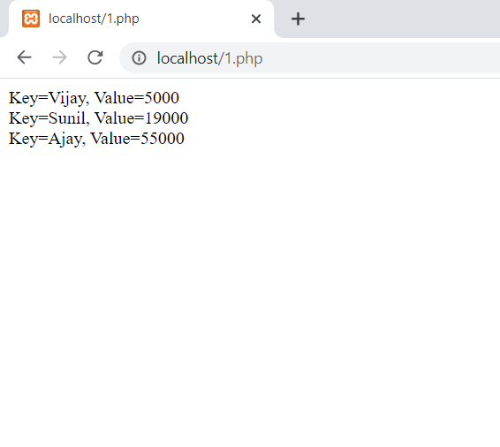

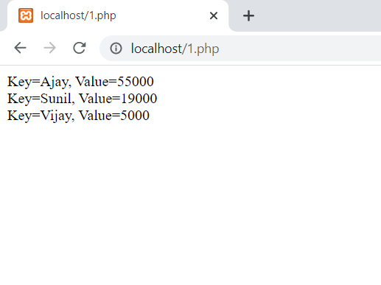

2.**write a php program to read character by character from a file and write all the vowels in an another file.**

<!DOCTYPE html>

<html>

<body>

<?php

$myfile = fopen("input.txt", "r") or die("Unable to open file!");

$myfile1 = fopen("output.txt", "w") or die("Unable to open file!");

while(!feof($myfile)) {

$char=fgetc($myfile);

if($char=='a'||$char=='e'||$char=='i'||$char=='o'||$char=='u')

fwrite($myfile1,$char). "<br>";

}

fclose($myfile);

?>

</body>

</html>

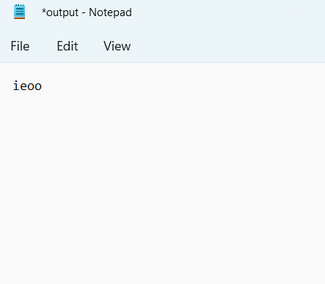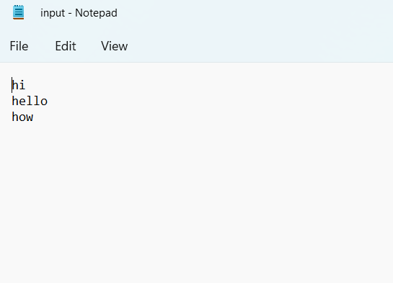

4. **write a program to retrieve record from database and print it in a tabular form**

**Consider: Table name:emp**

**Fields:name(varchar),code(int),designation(varchar),salary(int).**

<!DOCTYPE html>

<html>

<body>

<?php

$servername = "localhost";

$username = "root";

$password = "";

$dbname = "mydb";

$conn = mysqli_connect($servername, $username, $password, $dbname);

if (!$conn)

{

die("Connection failed: " . mysqli_connect_error());

}

$sql = "SELECT * FROM emp";

$result = mysqli_query($conn, $sql);

if (mysqli_num_rows($result) > 0)

{

echo "<table border=1>";

echo "<tr>";

echo "<th>NAME</th>";

echo "<th>CODE</th>";

echo "<th>DESIGNATION</th>";

echo "<th>SALARY</th>";

echo "</tr>";

while ($row = mysqli_fetch_array($result))

{

echo "<tr>";

echo "<td>".$row['name']."</td>";

echo "<td>".$row['code']."</td>";

echo "<td>".$row['designation']."</td>";

echo "<td>".$row['salary']."</td>";

echo "</tr>";

}

echo "</table>";

mysqli_free_result($result);

}

else {

echo "No matching records are found.";

}

mysqli_close($conn);

?>

</body>

</html>

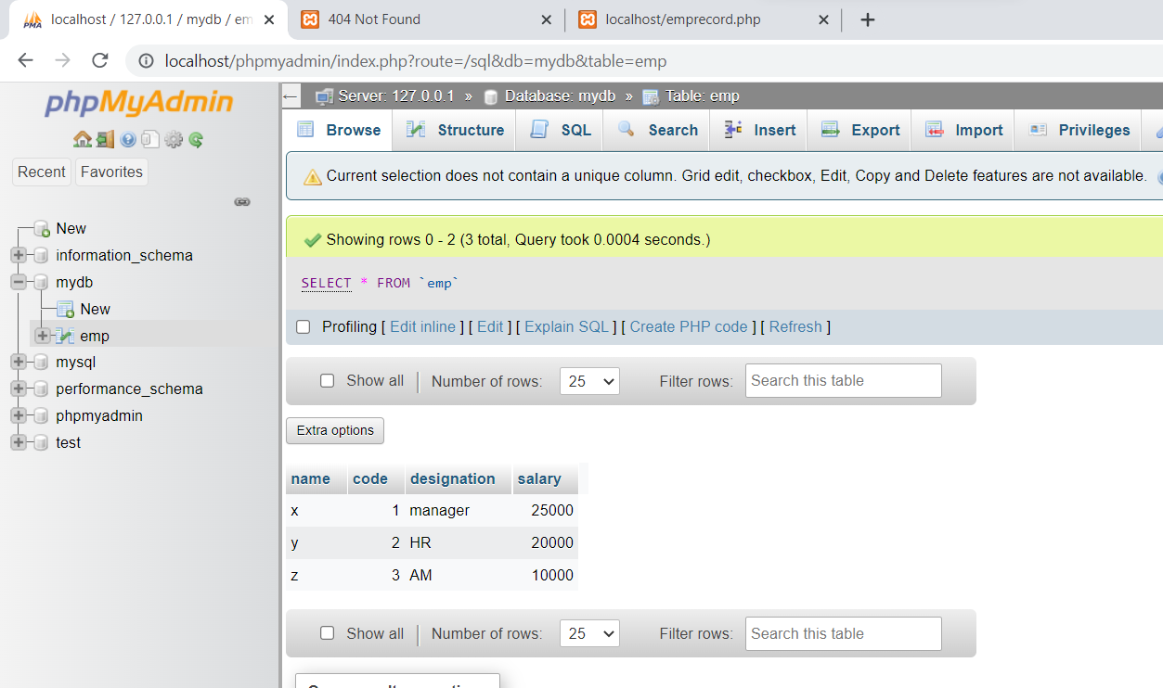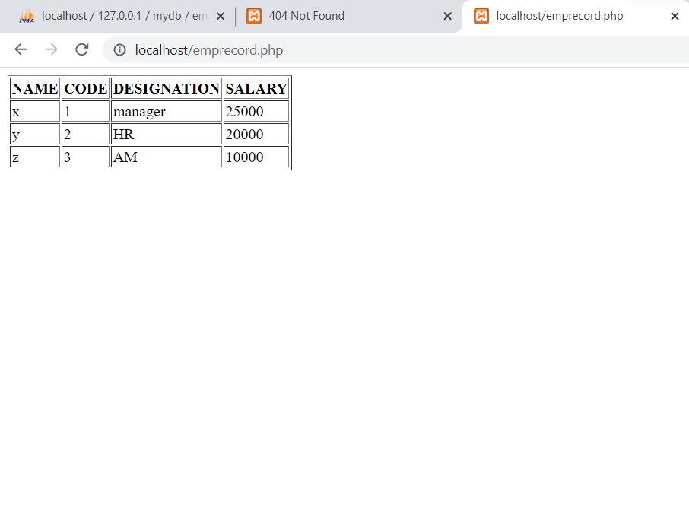

5.**write a php program to create a HTML form with following inputs**

**Name,code,designation,salary**

**Submit the form data into a php program .php code will accept all the values and insert into a database.**

**FORM.html**

<!DOCTYPE html>

<html>

<head>

<title>PHP insertion</title>

<body>

<div class="title">

<h2>Insert Data In Database Using PHP.</h2>

</div>

<form action="http://localhost/insertrecord.php" method="post">

<h2>Form</h2>

<label>NAME:</label>

<input class="input" name="nm" type="text" value="">

<label>CODE:</label>

<input class="input" name="cd" type="text" value="">

<label>DESIGNATION:</label>

<input class="input" name="ds" type="text" value="">

<label>SALARY:</label>

<input class="input" name="sal" type="text" value="">

<input class="submit" name="submit" type="submit" value="Insert">

</form>

</body>

</html>

**INSERTRECORD.php**

<!DOCTYPE html>

<html>

<body>

<?php

if(isset($_POST['submit']))

{

$ename = $_POST['nm'];

$ecode = $_POST['cd'];

$edesig = $_POST['ds'];

$esal = $_POST['sal'];

$servername = "localhost";

$username = "root";

$password = "";

$dbname = "mydb";

//create connection

$conn = mysqli_connect($servername, $username, $password, $dbname);

// Check connection

if (!$conn)

{

die("Connection failed: " . mysqli_connect_error());

}

$sql = "INSERT INTO emp VALUES ('$ename','$ecode','$edesig','$esal')";

if (mysqli_query($conn, $sql)) {

echo "New record created successfully";

} else {

echo "Error: " . $sql . "<br>" . mysqli_error($conn);

}

mysqli_close($conn);

}

?>

</body>

</html>

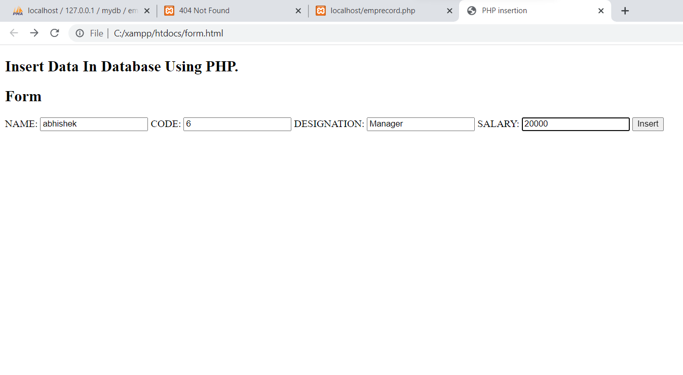

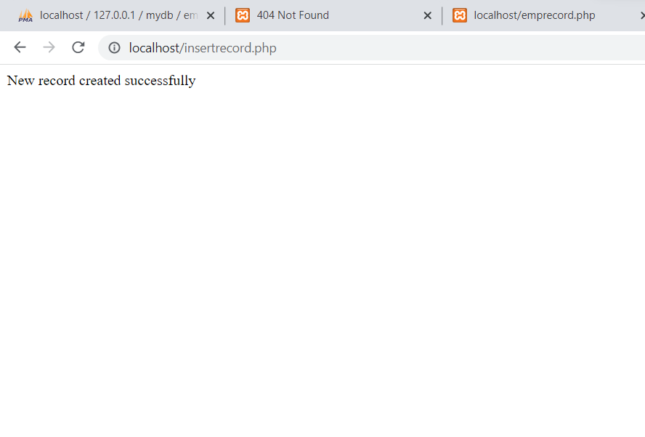

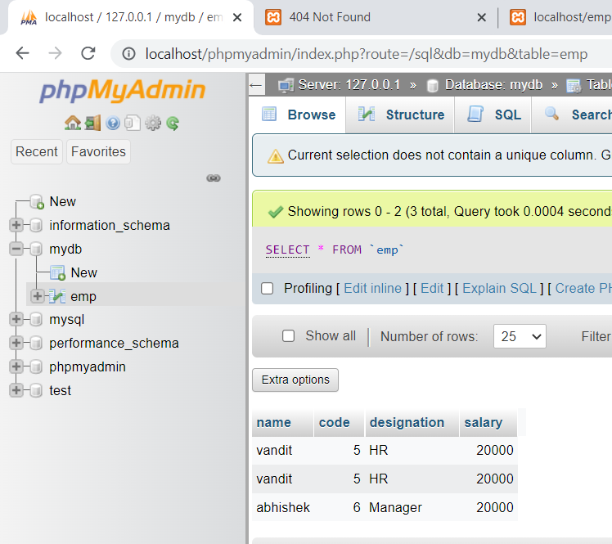

6.**write a program to update salary of an employee according to employee code.**

**search.html**

<!DOCTYPE html>

<html>

<head>

<title>PHP insertion</title>

<body>

<div class="title">

<h2>Insert Data In Database Using PHP.</h2>

</div>

<form action="http://localhost/insertrecord.php" method="post">

<h2>Form</h2>

<label>NAME:</label>

<input class="input" name="nm" type="text" value="">

<label>CODE:</label>

<input class="input" name="cd" type="text" value="">

<label>DESIGNATION:</label>

<input class="input" name="ds" type="text" value="">

<label>SALARY:</label>

<input class="input" name="sal" type="text" value="">

<input class="submit" name="submit" type="submit" value="Insert">

</form>

</body>

</html>

**Update.php**

<!DOCTYPE html>

<html>

<body>

<?php

if(isset($_POST['submit']))

{

$ecode = $_POST['cd'];

$servername = "localhost";

$username = "root";

$password = "";

$dbname = "mydb";

//create connection

$conn = mysqli_connect($servername, $username, $password, $dbname);

// Check connection

if (!$conn)

{

die("Connection failed: " . mysqli_connect_error());

}

$sql="UPDATE emp SET salary=salary+5001 WHERE code='$ecode'";

if (mysqli_query($conn, $sql))

{

echo "Record update successfully";

}

else

{

echo "Error: " . $sql . "<br>" . mysqli_error($conn);

}

mysqli_close($conn);

}

?>

</body>

</html>

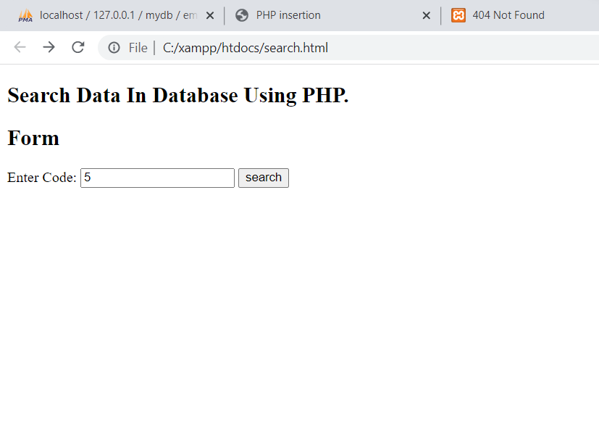



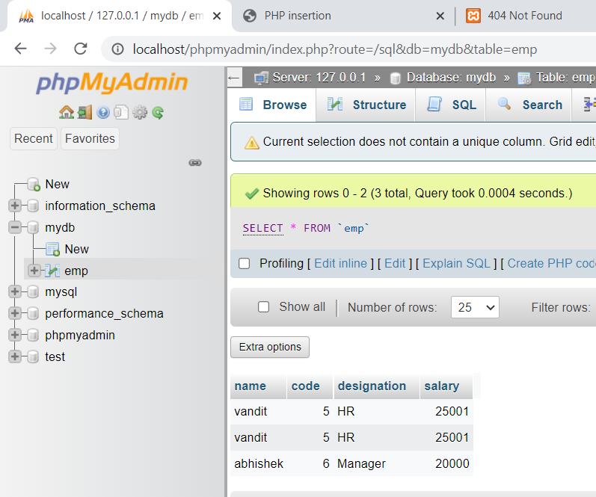

**BEFORE UPDATE**

**AFTER UPDATE**

7.**write a program to delete particular employee record according to his code.**

**Delete.html**

<!DOCTYPE html>

<html>

<body>

<div class="title">

<h2>Search Data In Database Using PHP.</h2>

</div>

<form action="http://localhost/delete.php" method="post">

<h2>Form</h2>

<label>Enter Code:</label>

<input class="input" name="cd" type="text" value="">

<input class="submit" name="submit" type="submit" value="delete">

</form>

</body>

</html>

**Delete.php**

<!DOCTYPE html>

<html>

<body>

<?php

if(isset($_POST['submit']))

{

$ecode = $_POST['cd'];

$servername = "localhost";

$username = "root";

$password = "";

$dbname = "mydb";

//create connection

$conn = mysqli_connect($servername, $username, $password, $dbname);

// Check connection

if (!$conn)

{

die("Connection failed: " . mysqli_connect_error());

}

$sql="delete from emp WHERE code='$ecode'";

if (mysqli_query($conn, $sql))

{

echo "Record deleted successfully";

}

else

{

echo "Error: " . $sql . "<br>" . mysqli_error($conn);

}

mysqli_close($conn);

}

?>

</body>

</html>

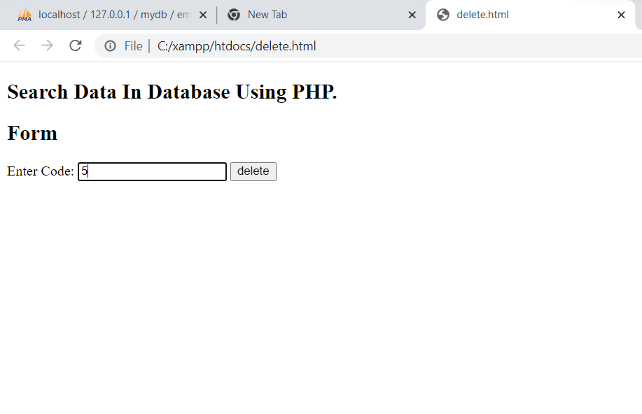



**BEFORE DELETE**

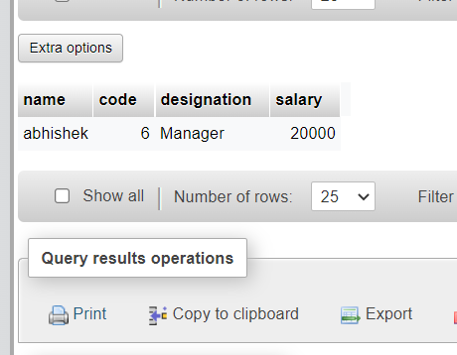

**AFTER DELETE**

3.**write a program to maintain sesson of a particular user in different pages. At the end if user want to logout,then destroy the session.**

Myfile.html

<html>

<body>

<a href="http://localhost/session1.php">Call Session program</a>

</body>

</html>

Session1.php

<?php

session_start();

?>

<html>

<body>

<?php

$_SESSION["user"] = "geu";

echo "Session information are set successfully.<br/>";

?>

<a href="http://localhost/welcome.php">Visit next page</a>

</body>

</html>

Welcome.php

<?php

session_start();

?>

<html>

<body>

<?php

echo "User is: ".$_SESSION["user"];

echo "Hello: " .$_SESSION["user"];

?>

<br>

<br>

<a href="http://localhost/session1.php">go back</a><br>

<a href="http://localhost/logout.php">click here for logout</a>

</body>

</html>

Logout.php

<?php

session_start();

session_destroy();

echo”session destroyed successfully”;

?>